Chapter 13, Problem 33.

Determine the input impedance of the air-core transformer circuit of Fig. 13.101.

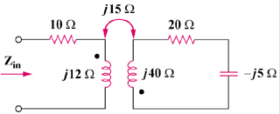

Figure 13.101
For Prob. 13.33.

